**calderdale retreat**

**OCTOBER 2020**

**2020 Newsletter**

**DON’T WORRY, BE HAPPY**

As we are, unfortunately still in the midst of Covid, we are doing our absolute best to maintain the exciting days for the Residents. We never run out of ideas to keep everyone active and happy! The hardest part of course is us still being in lockdown, but we have got to stay positive and just hope for this all to change as soon as possible.

Love Team Retreat

“In this together – Always”

**

This month we have tried to calm down on the cake, believe it or not! We have filled up the days with plenty of refreshing drinks along with puzzles, of course!

**PAMPER DAYS**

**Our Pamper Days are still happening every Tuesday! We know how much everyone enjoys this day and would not change it for the world!**

**No month is complete without our themed days! Take a look at Mexican Day and First Aid Day!**

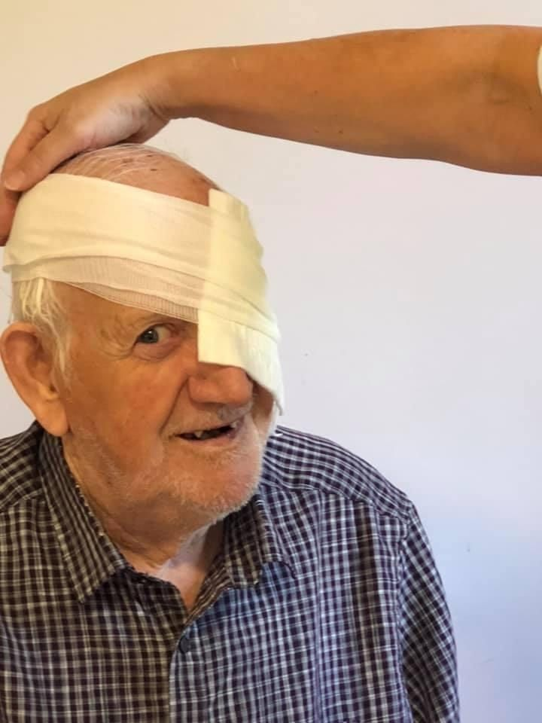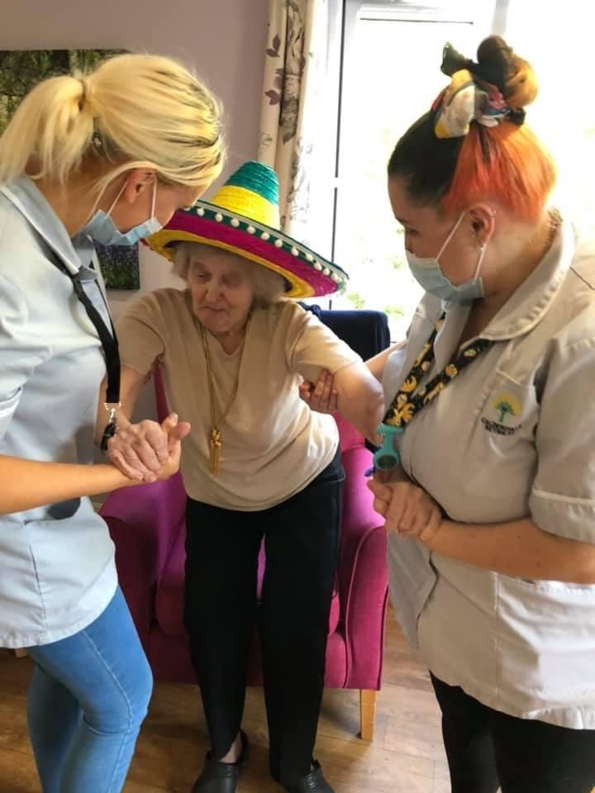 

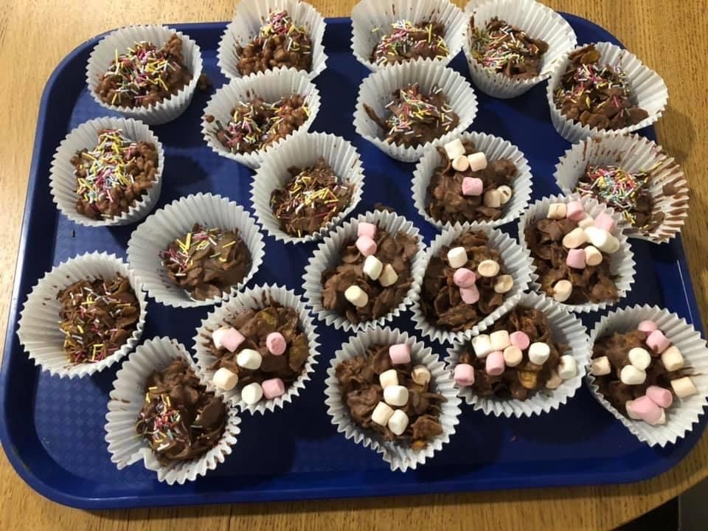



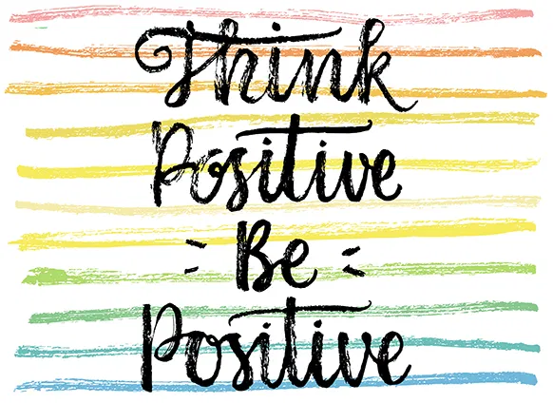

**Quote of the Month**

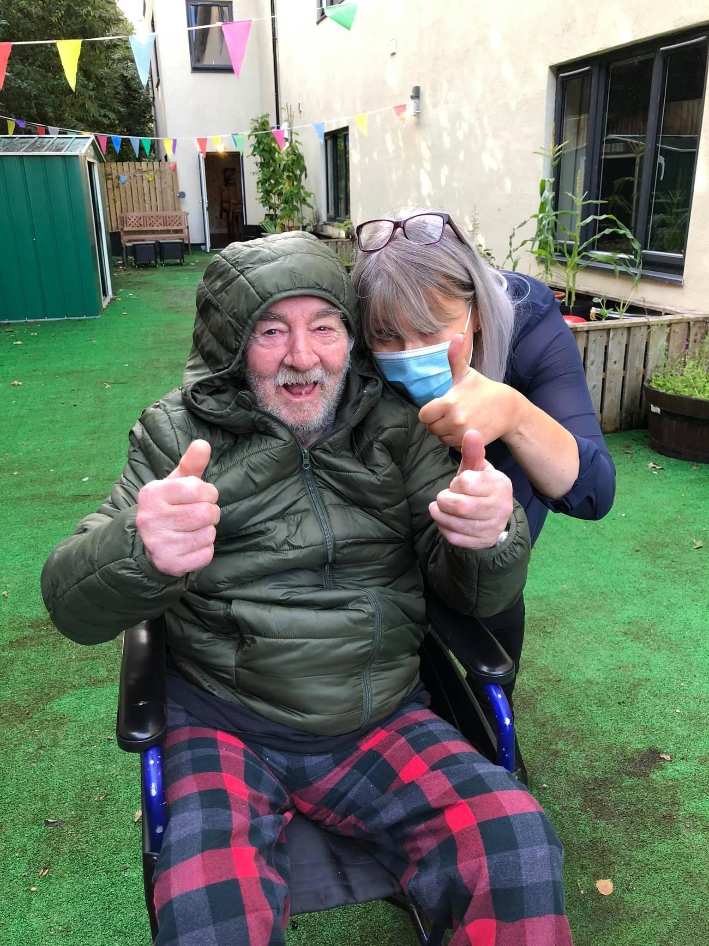

**UPDATES**

**Unfortunately, we are still in lockdown, however we will get through this! It is such a difficult time and we want to thank everyone who has understood these guidelines and respected our vision, which is to keep everyone safe.**

**We have spent the month trying to get outdoors as much as possible before the winter weather hits us.**

**WE ARE PROUD TO BE A PART OF TEAM RETREAT**

